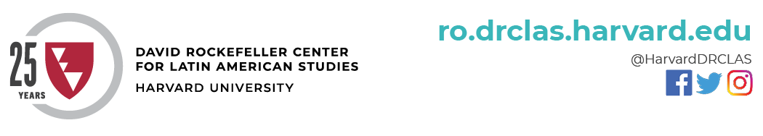

Av. Dag Hammarskjold 3269 3rd Floor, | Vitacura, Chile | +56 (22) 290-0300 | ro.drclas.harvard.edu

**MBA Admissions in Santiago**

Wednesday, July 17

Potential MBA candidates will meet local alumni to learn more about the program, the renowned case method, and information on the admissions process, led by [**Chad Losee**](https://www.hbs.edu/news/releases/Pages/new-admissions-financial-aid-director.aspx)(HBS)

*In collaboration with HBS*

**CASA Chile Fall 2019**

Monday, July 22 – Mid-December

8 students have confirmed participation in the Consortium for Advanced Studies Abroad led by Harvard, Chile Fall 2019 program, from the following universities: Barnard, Brown, Johns Hopkins, Swarthmore, and Vanderbilt

**CASA Argentina Fall 2019**

Monday, July 22 – Mid-December

6 students have confirmed participation in the Consortium for Advanced Studies Abroad led by Harvard, Argentina Fall 2019 program from the following universities: Brown, John Hopkins,and Swarthmore

**Creating Emerging Markets Project**

August-Fall 2019

[**Geoffrey Jones**](https://www.hbs.edu/faculty/Pages/profile.aspx?facId=24276)(HBS) and Andrea Lluch will conduct interviews with Chilean business leaders for his project which explores high impact leaders in business and social enterprise.

**Modern Ruins – International Seminar**

Friday, August 9

Full day conference on the phenomenon of modern ruins in architecture, urbanism and art, with emphasis on local heritage with keynote speaker [**Giuliana Bruno**](https://www.gsd.harvard.edu/person/giuliana-bruno/)(GSD)

*Organized by Universidad Católica in collaboration with Arts@DRCLAS*

**Latin American Research Center (LARC) Presentation**

Tuesday, August 20

[**Fernanda Miguel**](https://www.hbs.edu/global/about/Pages/latin-america.aspx)**,** LARC Director (HBS) will present a case study (CUMPLO) and its protagonist, Nicolás Shea

*In collaboration with LARC and Harvard Club de Chile*

**Summer Internship Program Argentina**

Monday, June 3 – Friday, July 26

20 Harvard Undergraduate students will be participating in the two-month internship program at local institutions

**Summer Internship Program Chile**

Monday, June 3 – Friday, July 26

10 Harvard Undergraduate students will be participating in the two-month internship program at local institutions

**Harvard Summer School**

Monday, June 3 – Friday, July 26

12 Harvard Undergraduate students will participate in this year’s HSS course, “Cultural Immersion and Public Health in Santiago, Chile” with Professor [**Adriana Gutiérrez**](https://rll.fas.harvard.edu/people/adriana-guti%C3%A9rrez) (RLL)

*In collaboration with Universidad de Chile*

**The Behavior of Corporate Governments in Chile**

Wednesday, June 26

A presentation led by [**Gonzalo Jiménez**](https://www.luksicscholars.org/en/story/gonzalo-jimenez/), DRCLAS Luksic Visiting Scholar (2001)

*In collaboration with the Harvard Club de Chile*

**Smithsonian Astrophysical Observatory Advisory Board Meeting in Chile**

Sunday, June 30

[**Charles Alcock**](https://www.cfa.harvard.edu/do/alcock.html) (Director, Harvard-Smithsonian Center for Astrophysics) led the biannual Advisory Board meeting in Chile before travelling to the solar eclipse with the Board on July 2

**Technologies for Citizen Participation in the Legislative Process**

Monday, July 8

A panel led by Harvard-UAI Collaborative Research Grant winners, [**Victoria Alsina Burgués**](https://scholar.harvard.edu/alsinaburgues/home) (HKS Ash Center), UAI partners, and local Senators

*In collaboration with Universidad Adolfo Ibáñez, Chilean Senate, Chilean Chamber of Deputies*